Troop 64 Menu Planner
ITEMS NEEDED TO PREPARE MEALS
Equipment | Provided | Need
SHOPPING LIST
Item | Quantity
Attendance
PL. | 5.
2. | 6.
3. | 7.
4. | 8.
MenuS
Day:______  Meal:______ | Main Dish:
 | Side 1:
 | Side 2:
 | Other:
 | Beverage:
Day:______  Meal:______ | Main Dish:
 | Side 1:
 | Side 2:
 | Other:
 | Beverage:
Day:______  Meal:______ | Main Dish:
 | Side 1:
 | Side 2:
 | Other:
 | Beverage:
Day:______  Meal:______ | Main Dish:
 | Side 1:
 | Side 2:
 | Other:
 | Beverage:
Day:______  Meal:______ | Main Dish:
 | Side 1:
 | Side 2:
 | Other:
 | Beverage:
Day:______  Meal:______ | Main Dish:
 | Side 1:
 | Side 2:
 | Other:
 | Beverage:
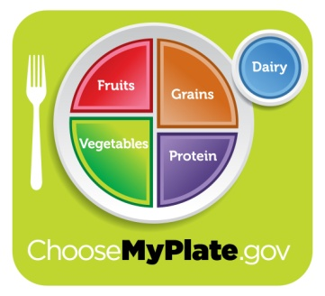
APPROVALS

Patrol Leader: ________________________

Senior Patrol Leader: __________________

Assistant Scoutmaster: _______________

Assistant Scoutmaster must approve all menus
prior to Grubmaster to purchasing any food.
Attach receipts to this form. Return to Troop Scribe at next troop meeting following campout. Grubmaster will be reimbursed for $____ per Scout (only if receipts are present).
Budget

$_____ x _____ = $______
$/Scout x # Scouts = Total
Budget

Total Spent $__________

Change Due $_________
At a minimum, your daily selections should include:

- 2 proteins;
- 2 vegetables or fruits;
- 2 grains; and
- 2 dairy products.
Patrol:___________________

Grubmaster:______________

Campout:________________

Dates:___________________
Grubmaster is responsible for:
- Purchasing patrol food;
- Packing food in issued bin/cooler;
- Food/ice/cooler during campout; and
- Cleanup of bin/cooler after campout.
Consider the five basic food groups when planning your meals:
Protein (meat, fish poultry, lentils, beans, dried peas);
Vegetables (leafy green, yellow and other vegetables);
Fruits (citrus fruits, apples, bananas, tomatoes);
Grains (bread, pasta, rice, oatmeal, granola); and
Dairy (milk, cheese, yogurt).

